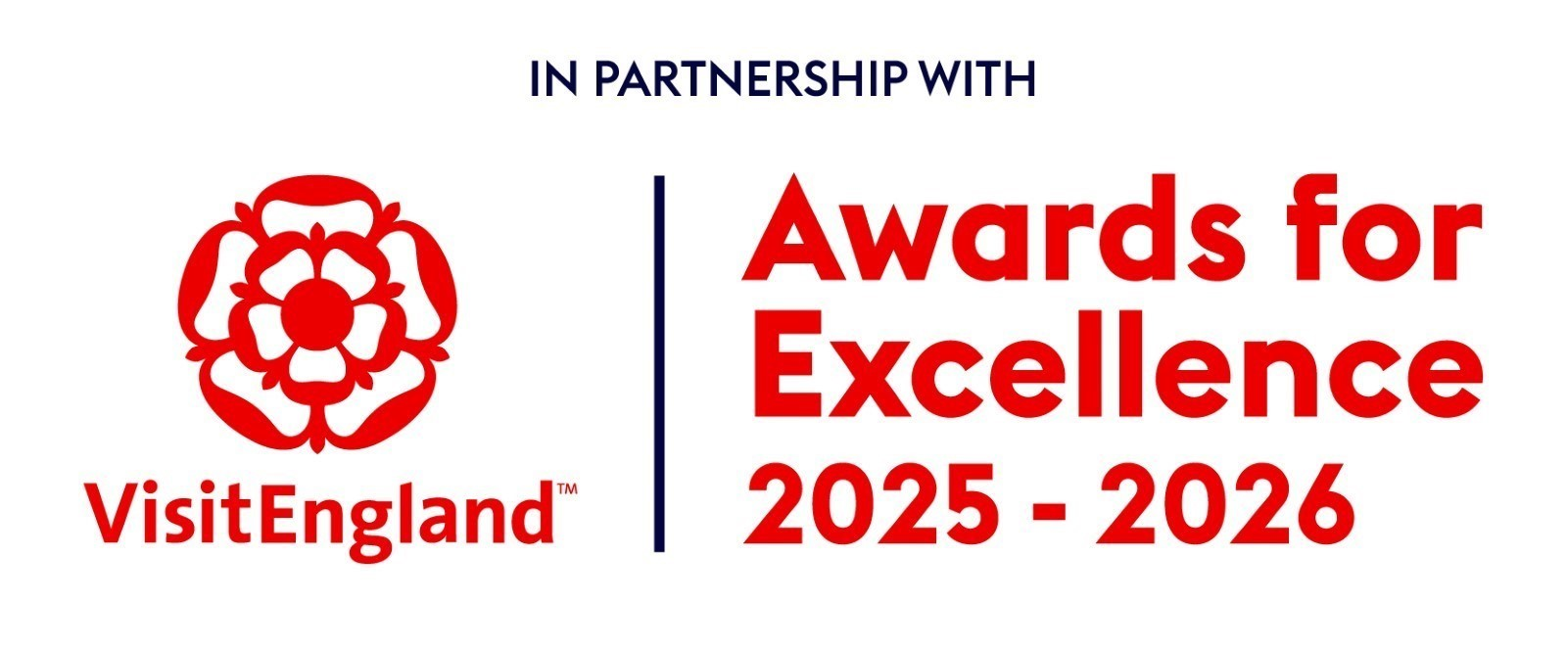

# **Wedding Venue**

# **of the Year**

Recognises venues for providing truly memorable wedding experiences for couples in Cheshire and Warrington.

**This sample application form is for information only and all applications must be made via the online application system. It is recommended that you complete this form in draft off-line, then submit details via the online application system afterwards.**

## Eligibility criteria

* The venue must be registered to hold weddings
* It can be any size and style but must be in Cheshire
* The judges will be looking for excellence within every department and across every aspect of the business and a truly memorable experience
* Must be open for business 12 September and 14 November 2025. Please also advise us if you are closed during any other period.
* If you have any questions, please email [awards@marketing.cheshireandwarrington.com](mailto:awards@marketingcheshire.co.uk)
* The judging will be based on this entry form, your website (viewed on desktop, mobile and tablet), and any other online presence that you might have, including social media. The judges will also look at your online customer reviews
* There is no requirement for businesses to be quality assessed by VisitEngland, the AA or any other assessing body.
* **If there is any other information (not available online) that you would like to include to illustrate points made in your entry, for example, regional or national press coverage, please upload one pdf document no larger than 5mb. If more than one document is sent or it is larger than 5mb it cannot be sent on to the judges. Please ensure each piece of evidence is indexed to the relevant question.**
* Please try to answer all questions as fully as possible, but within the word limit. At the end of each question you may include web links, if you have them, to support your answer. These can be in addition to the word count.
* Please ensure you read the awards terms and conditions.

## Applicant & business details

**Applicant’s name: (The person we should contact regarding this entry. The email given here will be the email address we use for all future correspondence).**

Enter the applicant’s name here.

**Applicant’s job title:**

**Applicant’s phone number:**  
  
**Applicant’s email:**

Enter the applicant’s job title here.

**Business name:**

Detail the business name you use when promoting your business, as you wish it to appear in all publicity materials. This will be used on any winner trophy, certificate, in awards presentation, press content and any awards related collateral.

Enter name here.

**Business address:**

Enter address here.

**Promotional Description**

Provide a promotional description of your business.

* Focus on business strengths and stand out features
* Write your description with regard to this category
* This wording will be used in PR and awards literature if you are shortlisted as a finalist
* Wording provided is subject to edit
* 120 words maximum

**Promotional Images**

Provide up to three landscape high resolution photos.

* Photos should relate to this category
* Photos should be high quality and truly showcase your wedding venue
* Photos should not be edited in any way eg embedded text or logos, a collage
* Only include photos that you own the copyright for
* If the photo requires a credit eg photographer, please provide details
* These photos will be used in PR and awards literature if you are shortlisted as a finalist

## Background

**Briefly outline the story of your venue (250 words maximum).**

For example:

* Length of time business has been under current ownership
* Target market(s) and typical customer profile
* Key milestones in developing the wedding business
* Indication of size wedding market for the business
* Number of staff employed, if any

Enter information on the background of your event here.

**List any awards, ratings and accolades received in the last two years. Include the title, awarding body, level and date (including year) achieved.**

For example:

* Successes in this competition
* TripAdvisor Accolades
* Green Tourism award
* Certificate of Excellence
* Local business award eg FSB, Chamber of Commerce

Enter information on any awards, ratings or accolades here.

**There is no requirement for your business to be quality assessed. However, if you have an independent quality assessment/mystery shopping report from the last two years, you might wish to upload it here (optional).**

Enter information on any quality assessments here.

## Online presence & reviews

**Provide links to your online presence relating to this category, which will be reviewed and scored by judges in addition to your answers to the four questions. Other sites may also be checked.**

Enter the website URL here.

**Social media platforms**

**Online Review Sites**

**Customer Service: How do your ensure that your clients and their guests have an enjoyable and memorable experience?**

**What improvements have you made to your business to improve customer experiences within the last 2 years?**

**Tell us about about innovative marketing you have used to attract new business to the venue and what was the result? (500 words maximum).**

**What makes your food offering special for wedding guests?**

## **Have you made a significant and / or special contribution in the areas of accessibility, inclusion and sustainability? If so, what prompted this action?**

**Sum up what makes your business unique and why you should win this award?**