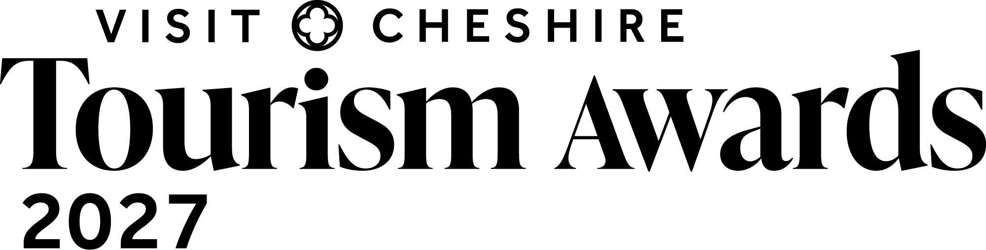

Team of the Year

Recognises visitor economy teams in Cheshire and Warrington for their commitment and dedication to the business.

This sample application form is for information only and all applications must be made via the online application system.

It is recommended that you log into the Visit Cheshire application portal now to register which award(s) you will be applying for and input basic details. You will receive system updates with helpful information on the application process and reminder to ensure the application deadline is not missed.
Link here: https://visitengland-chapters.secure-platform.com/a/organizations/CHE/home

This sample application form can be used as an off-line resource to pre-edit, collaborate, approve and finalise the wording with colleagues as required, before copying and pasting into the online portal.

Eligibility criteria

- Any team who works within the Cheshire and Warrington visitor economy sector can enter this award
- The judges will be looking for excellence in teamwork
- Must have worked as a team for at least 8 weeks during the 12-month period prior to 12 June 2026
- If you have any questions, please email awards@marketing.cheshireandwarrington.com
- The judging will be based on this entry form, your website (viewed on desktop, mobile and tablet), and any other online presence that you might have, including social media. The judges will also look at your online customer reviews
- There is no requirement for businesses to be quality assessed by VisitEngland, the AA or any other assessing body.
- If there is any other information (not available online) that you would like to include to illustrate points made in your entry, for example, regional or national press coverage, please upload one pdf document no larger than 5mb. If more than one document is sent or it is larger than 5mb it cannot be sent on to the judges. Please ensure each piece of evidence is indexed to the relevant question.
- Please try to answer all questions as fully as possible, but within the word limit. At the end of each question you may include web links, if you have them, to support your answer. These can be in addition to the word count.
- Please ensure you read the awards terms and conditions on the website

Applicant & business details

Applicant’s name: (The person we should contact regarding this entry. The email given here will be the email address we use for all future correspondence).

Applicant’s job title:

Applicant’s phone number:
Applicant’s email:
Business address:

Team being nominated and Business name:
Detail the names as you wish it to appear in all publicity materials. This will be used on any winner trophy, certificate, in awards presentation, press content and any awards related collateral.

Promotional Description
Provide a promotional description of your team and business.
- Focus on business strengths and stand out features
- Write your description with regard to this category
- This wording will be used in PR and awards literature if you are shortlisted as a finalist
- Wording provided is subject to edit
- 120 words maximum
Promotional Images
Provide up to three landscape high resolution photos.
- Photos should relate to this category
- Photos should be high quality and truly showcase your wedding venue
- Photos should not be edited in any way eg embedded text or logos, a collage
- Only include photos that you own the copyright for, if the photo requires a credit eg photographer, please provide details
- These photos will be used in PR and awards literature if you are shortlisted as a finalist

Question 1 – Outline the team’s role

Briefly outline the team’s role (200 words maximum).
For example:
- Length of time the team has been established (note must be minimum of 8 weeks during last 12 month period)
- Possible key milestones reached by the team
- What is involved in their day-to-day role

Question 2 – awards and achievements

List any awards, ratings and accolades achieved in the last two years by the nominated team. Include the title, awarding body, level and dates (including year) achieved.
For example:
- Successes in this competition
- Online feedback and reviews such as TripAdvisor Accolades, Google review, social media reviews
- Customer feedback in person, on site
- Certificate of Excellence
- Local or national business award eg FSB, Chamber of Commerce

Question 3 – business success
Explain how the team have contributed to the success of the business

For example:
- How are they integral to the running of the business?
- What training and qualifications have they undertaken that impacts their role?
- What successful campaigns or projects have they contributed to?
- How does the team impact the customer experience?

Question 4 – Summary

Sum up what makes the team invaluable to your business. Why should they win this award?

